Министерство образования Республики Беларусь
Учреждение образования
«Белорусский государственный университет информатики и радиоэлектроники»

Кафедра электронных вычислительных машин

Лабораторная работа №5
по дисциплине «Программирование на языках высокого уровня»
« Batch data processing & Testing»

Выполнил: Проверил:
Снитко Д.А. ассистент Скиба И.Г.
гр.250501

Минск 2024
1. Постановка задачи

1.Добавить POST метод для работы со списком параметров (передаются в теле запроса) для bulk операций, организовать работу сервиса используя Java 8 (Stream API, лямбда-выражения).
2. Покрытие Unit-тестами на >80% (бизнес-логика).

2. Структура проекта
В проекте используется послойная архитектура из нескольких пакетов,
которые отвечают за определенные функции.

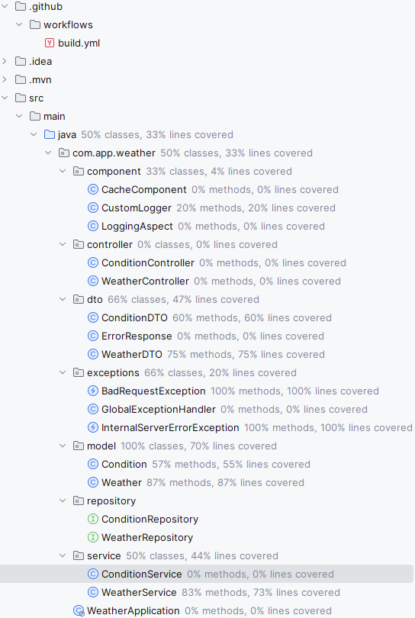
Рисунок 2.1 – Структура проекта
3. Листинг кода

Файл ConditionServiceTest.java

class ConditionServiceTest {

@Mock
private ConditionRepository conditionRepository;
@Mock
private CacheComponent cache;
@Mock
private CustomLogger customLogger;
private ConditionService conditionService;

@BeforeEach
void setup() {
MockitoAnnotations.initMocks(this);
conditionService = new ConditionService(conditionRepository, cache, customLogger);
}

@Test
void testCreateCondition() {
Condition condition = new Condition();
condition.setId(1L);
condition.setText("Sunny");
when(conditionRepository.save(condition)).thenReturn(condition);

Condition createdCondition = conditionService.createCondition(condition);

assertEquals(condition, createdCondition);
verify(conditionRepository, times(1)).save(condition);
verify(cache, times(1)).put(condition.getId().toString(), createdCondition);
}

@Test
void testCreateConditionWithExistingTextThrowsBadRequestException() {
Condition condition = new Condition();
condition.setText("Sunny");

when(conditionRepository.existsByText(condition.getText())).thenReturn(true);

assertThrows(BadRequestException.class, () -> conditionService.createCondition(condition));
verify(conditionRepository, never()).save(condition);
verify(cache, never()).put(anyString(), any(Condition.class));
}

@Test
void testUpdateCondition() {
Condition existingCondition = new Condition();
existingCondition.setId(1L);
existingCondition.setText("Sunny");

ConditionDTO conditionDTO = new ConditionDTO();
conditionDTO.setText("Cloudy");

when(conditionRepository.findById(existingCondition.getId())).thenReturn(Optional.of(existingCondition));
when(conditionRepository.save(existingCondition)).thenReturn(existingCondition);

Condition updatedCondition = conditionService.updateCondition(existingCondition.getId(), conditionDTO);

assertEquals(conditionDTO.getText(), updatedCondition.getText());
verify(conditionRepository, times(1)).save(existingCondition);
}

@Test
void testUpdateConditionWithNonExistingIdThrowsBadRequestException() {
ConditionDTO conditionDTO = new ConditionDTO();
conditionDTO.setText("Cloudy");

when(conditionRepository.findById(1L)).thenReturn(Optional.empty());

assertThrows(InternalServerErrorException.class, () -> conditionService.updateCondition(1L, conditionDTO));
verify(conditionRepository, never()).save(any(Condition.class));
verify(cache, never()).put(anyString(), any(Condition.class));
}

@Test
void testDeleteCondition() {
Condition condition = new Condition();
condition.setId(1L);
condition.setText("Test condition");
when(conditionRepository.save(condition)).thenReturn(condition);
when(conditionRepository.findById(condition.getId())).thenReturn(Optional.of(condition));
when(conditionRepository.existsById(condition.getId())).thenReturn(true);

conditionService.createCondition(condition);

Long id = condition.getId();

conditionService.deleteCondition(id);

verify(conditionRepository, times(1)).deleteById(id);
verify(cache, times(1)).remove(id.toString());
}

@Test
void testGetConditionById() {
Condition condition = new Condition();
condition.setId(1L);
condition.setText("Sunny");

when(conditionRepository.findById(condition.getId())).thenReturn(Optional.of(condition));

Condition foundCondition = conditionService.getConditionById(condition.getId());

assertEquals(condition, foundCondition);
verify(conditionRepository, times(1)).findById(condition.getId());
verify(cache, times(1)).put(condition.getId().toString(), foundCondition);
}

@Test
void testGetConditionByIdWithNonExistingIdThrowsBadRequestException() {
Long id = 1L;

when(conditionRepository.findById(id)).thenReturn(Optional.empty());

assertThrows(InternalServerErrorException.class, () -> conditionService.getConditionById(id));
verify(cache, never()).put(anyString(), any(Condition.class));
}

@Test
void testGetAllConditions() {
List<Condition> conditions = new ArrayList<>();
conditions.add(new Condition());
conditions.add(new Condition());

when(conditionRepository.findAll()).thenReturn(conditions);

assertThrows(InternalServerErrorException.class, () -> conditionService.getAllConditions());

verify(conditionRepository, times(1)).findAll();
}

@Test
void testGetConditionByText() {
String text = "Sunny";
Condition condition = new Condition();
condition.setId(1L); // устанавливаем идентификатор
condition.setText(text);

when(conditionRepository.findByText(text)).thenReturn(condition);

Condition foundCondition = conditionService.getConditionByText(text);

assertEquals(condition, foundCondition);
verify(conditionRepository, times(1)).findByText(text);
verify(cache, times(1)).put(foundCondition.getId().toString(), foundCondition);
}

@Test
void testGetConditionByTextWithNonExistingTextReturnsNull() {
String text = "Sunny";
when(conditionRepository.findByText(text)).thenReturn(null);
Condition condition = conditionService.getConditionByText(text);
assertNull(condition);
verify(conditionRepository, times(1)).findByText(text);
verify(cache, never()).put(anyString(), any(Condition.class));
}

@Test
void testCreateConditionBulk() {
List<ConditionDTO> conditionDTOs = new ArrayList<>();
conditionDTOs.add(new ConditionDTO(null, "Sunny"));
conditionDTOs.add(new ConditionDTO(null, "Cloudy"));
conditionDTOs.add(new ConditionDTO(null, "Rainy"));

when(conditionRepository.existsByText(anyString())).thenReturn(false);
when(conditionRepository.save(any(Condition.class))).thenAnswer(invocation -> invocation.getArgument(0));

List<Condition> createdConditions = conditionService.createConditionBulk(conditionDTOs);

assertEquals(3, createdConditions.size());
verify(conditionRepository, times(3)).save(any(Condition.class));
verify(cache, never()).put(anyString(), any(Condition.class));
}

@Test
void testUpdateNonExistingConditionThrowsBadRequestException() {
ConditionDTO conditionDTO = new ConditionDTO(null, "Cloudy");

when(conditionRepository.findById(1L)).thenReturn(Optional.empty());

assertThrows(InternalServerErrorException.class, () -> conditionService.updateCondition(1L, conditionDTO));
verify(conditionRepository, never()).save(any(Condition.class));
verify(cache, never()).put(anyString(), any(Condition.class));
}

@Test
void testUpdateConditionWithExistingValueThrowsBadRequestException() {
Condition existingCondition = new Condition();
existingCondition.setId(1L);
existingCondition.setText("Sunny");

ConditionDTO conditionDTO = new ConditionDTO(null, "Cloudy");

when(conditionRepository.findById(existingCondition.getId())).thenReturn(Optional.of(existingCondition));
when(conditionRepository.existsByTextAndIdNot("Cloudy", existingCondition.getId())).thenReturn(true);

assertThrows(BadRequestException.class, () -> conditionService.updateCondition(1L, conditionDTO));

verify(conditionRepository, never()).save(any(Condition.class));
}

@Test
void testDeleteNonExistingConditionThrowsBadRequestException() {
when(conditionRepository.existsById(1L)).thenReturn(false);

assertThrows(BadRequestException.class, () -> conditionService.deleteCondition(1L));
verify(conditionRepository, never()).deleteById(anyLong());
verify(cache, never()).remove(anyString());
}

@Test
void testGetConditionByTextWithNonExistingTextThrowsInternalServerErrorException() {
String text = "Sunny";
when(conditionRepository.findByText(text)).thenThrow(new RuntimeException());

assertThrows(InternalServerErrorException.class, () -> conditionService.getConditionByText(text));
verify(conditionRepository, times(1)).findByText(text);
verify(cache, never()).put(anyString(), any(Condition.class));
}

}

Файл WeatherServiceTest.java

class WeatherServiceTest {

@Mock
private WeatherRepository weatherRepository;
@Mock
private ConditionRepository conditionRepository;

@Mock
private ConditionService conditionService;

@Mock
private CacheComponent cacheComponent;

@Mock
private CustomLogger customLogger;

@Captor
private ArgumentCaptor<Weather> weatherArgumentCaptor;

private WeatherService weatherService;

@BeforeEach
void setUp() {
MockitoAnnotations.initMocks(this);
weatherService = new WeatherService(weatherRepository, conditionService, cacheComponent, customLogger);
}

@Test
void testCreateWeatherBulkSuccess() {
List<WeatherDTO> weatherDTOs = new ArrayList<>();
WeatherDTO weatherDTO1 = new WeatherDTO();
weatherDTO1.setCity("London");
weatherDTO1.setTemperature(20.0);
weatherDTO1.setCondition(new ConditionDTO());
weatherDTO1.getCondition().setText("Cloudy");
weatherDTOs.add(weatherDTO1);

WeatherDTO weatherDTO2 = new WeatherDTO();
weatherDTO2.setCity("Paris");
weatherDTO2.setTemperature(25.0);
weatherDTO2.setCondition(new ConditionDTO());
weatherDTO2.getCondition().setText("Sunny");
weatherDTOs.add(weatherDTO2);

Condition condition1 = new Condition();
condition1.setText("Cloudy");
Condition condition2 = new Condition();
condition2.setText("Sunny");

when(conditionService.getConditionByText("Cloudy")).thenReturn(condition1);
when(conditionService.getConditionByText("Sunny")).thenReturn(condition2);
when(weatherRepository.save(any(Weather.class))).thenAnswer(invocation -> invocation.getArgument(0));

List<Weather> createdWeathers = weatherService.createWeatherBulk(weatherDTOs);

assertEquals(2, createdWeathers.size());
verify(conditionService, times(2)).getConditionByText(anyString());
verify(weatherRepository, times(2)).save(any(Weather.class));
}

@Test
void testCreateWeatherBulkCityAlreadyExists() {
List<WeatherDTO> weatherDTOs = new ArrayList<>();
WeatherDTO weatherDTO1 = new WeatherDTO();
weatherDTO1.setCity("London");
weatherDTO1.setTemperature(20.0);
weatherDTO1.setCondition(new ConditionDTO());
weatherDTO1.getCondition().setText("Cloudy");
weatherDTOs.add(weatherDTO1);

WeatherDTO weatherDTO2 = new WeatherDTO();
weatherDTO2.setCity("London");
weatherDTO2.setTemperature(25.0);
weatherDTO2.setCondition(new ConditionDTO());
weatherDTO2.getCondition().setText("Sunny");
weatherDTOs.add(weatherDTO2);

when(weatherRepository.existsByCity("London")).thenReturn(true);

assertThrows(BadRequestException.class, () -> weatherService.createWeatherBulk(weatherDTOs));
verify(weatherRepository, times(1)).existsByCity("London");
verify(conditionService, never()).getConditionByText(anyString());
verify(weatherRepository, never()).save(any(Weather.class));
}

@Test
void testCreateWeatherBulkTransaction() {
List<WeatherDTO> weatherDTOs = new ArrayList<>();
WeatherDTO weatherDTO1 = new WeatherDTO();
weatherDTO1.setCity("London");
weatherDTO1.setTemperature(20.0);
weatherDTO1.setCondition(new ConditionDTO());
weatherDTO1.getCondition().setText("Cloudy");
weatherDTOs.add(weatherDTO1);

WeatherDTO weatherDTO2 = new WeatherDTO();
weatherDTO2.setCity("Paris");
weatherDTO2.setTemperature(25.0);
weatherDTO2.setCondition(new ConditionDTO());
weatherDTO2.getCondition().setText("Sunny");
weatherDTOs.add(weatherDTO2);

Condition condition1 = new Condition();
condition1.setText("Cloudy");

when(conditionService.getConditionByText("Cloudy")).thenReturn(condition1);
when(conditionService.getConditionByText("Sunny")).thenThrow(new RuntimeException());
when(weatherRepository.save(any(Weather.class))).thenAnswer(invocation -> invocation.getArgument(0));

assertThrows(RuntimeException.class, () -> weatherService.createWeatherBulk(weatherDTOs));
verify(conditionService, times(2)).getConditionByText(anyString());
verify(weatherRepository, times(1)).save(any(Weather.class));
}

@Test
void testCreateWeatherWithConditionWhenConditionExistsShouldCreateWeather() throws BadRequestException, InternalServerErrorException {
// Подготовка данных
WeatherDTO weatherDTO = new WeatherDTO();
weatherDTO.setCity("City");
weatherDTO.setCondition(new ConditionDTO());
weatherDTO.getCondition().setText("Condition");

Condition condition = new Condition();
condition.setText("Condition");

Weather weather = new Weather();
weather.setCity("City");
weather.setCondition(condition);

when(conditionService.getConditionByText(weatherDTO.getCondition().getText())).thenReturn(condition);
when(weatherRepository.save(any(Weather.class))).thenReturn(weather);

// Вызов метода
Weather result = weatherService.createWeatherWithCondition(weatherDTO);

// Проверка результата
assertEquals(weather, result);
verify(conditionService, times(1)).getConditionByText(weatherDTO.getCondition().getText());
verify(weatherRepository, times(1)).save(weatherArgumentCaptor.capture());
Weather capturedWeather = weatherArgumentCaptor.getValue();
assertEquals("City", capturedWeather.getCity());
assertEquals(condition, capturedWeather.getCondition());
}

@Test
void testCreateWeatherWithConditionWhenConditionDoesNotExistShouldThrowBadRequestException() {
// Подготовка данных
WeatherDTO weatherDTO = new WeatherDTO();
weatherDTO.setCity("City");
weatherDTO.setCondition(new ConditionDTO());
weatherDTO.getCondition().setText("Condition");

when(conditionService.getConditionByText("NonExistentCondition")).thenThrow(new BadRequestException("Condition not found"));

// Вызов метода и проверка исключения
assertThrows(InternalServerErrorException.class, () -> weatherService.createWeatherWithCondition(weatherDTO));
verify(conditionService, times(1)).getConditionByText(weatherDTO.getCondition().getText());
verify(weatherRepository, never()).save(any(Weather.class));
}

@Test
void testCreateWeatherWithConditionWhenWeatherForCityAlreadyExistsShouldThrowBadRequestException() {
// Подготовка данных
WeatherDTO weatherDTO = new WeatherDTO();
weatherDTO.setCity("City");
weatherDTO.setCondition(new ConditionDTO());
weatherDTO.getCondition().setText("Condition");

Weather existingWeather = new Weather();
existingWeather.setCity("City");
existingWeather.setCondition(new Condition());
existingWeather.getCondition().setText("Condition");

when(weatherRepository.findByCity(weatherDTO.getCity())).thenReturn(existingWeather);

// Вызов метода и проверка исключения
assertThrows(InternalServerErrorException.class, () -> weatherService.createWeatherWithCondition(weatherDTO));
verify(weatherRepository, times(1)).findByCity(weatherDTO.getCity());
verify(weatherRepository, never()).save(any(Weather.class));
}

@Test
void testUpdateWeatherWhenWeatherExistsShouldUpdateWeather() throws BadRequestException, InternalServerErrorException {
// Подготовка данных
WeatherDTO weatherDTO = new WeatherDTO();
weatherDTO.setCity("City");
weatherDTO.setTemperature(25.0);
weatherDTO.setCondition(new ConditionDTO());
weatherDTO.getCondition().setText("Condition");

Condition condition = new Condition();
condition.setText("Condition");

Weather existingWeather = new Weather();
existingWeather.setId(1L);
existingWeather.setCity("City");
existingWeather.setTemperature(20.0);
existingWeather.setCondition(condition);

Weather updatedWeather = new Weather();
updatedWeather.setId(1L);
updatedWeather.setCity("City");
updatedWeather.setTemperature(25.0);
updatedWeather.setCondition(condition);

when(weatherRepository.findById(1L)).thenReturn(Optional.of(existingWeather));
when(conditionService.getConditionByText(weatherDTO.getCondition().getText())).thenReturn(condition);
when(weatherRepository.save(any(Weather.class))).thenReturn(updatedWeather);

// Вызов метода
Weather result = weatherService.updateWeather(1L, weatherDTO);

// Проверка результата
assertEquals(updatedWeather, result);
verify(weatherRepository, times(1)).findById(1L);
verify(conditionService, times(1)).getConditionByText(weatherDTO.getCondition().getText());
verify(weatherRepository, times(1)).save(weatherArgumentCaptor.capture());
Weather capturedWeather = weatherArgumentCaptor.getValue();
assertEquals("City", capturedWeather.getCity());
assertEquals(25.0, capturedWeather.getTemperature());
assertEquals(condition, capturedWeather.getCondition());
}

@Test
void testUpdateWeatherWhenWeatherDoesNotExistShouldThrowBadRequestException() {
// Подготовка данных
WeatherDTO weatherDTO = new WeatherDTO();
weatherDTO.setCity("City");
weatherDTO.setTemperature(25.0);
weatherDTO.setCondition(new ConditionDTO());
weatherDTO.getCondition().setText("Condition");

when(weatherRepository.findById(1L)).thenReturn(Optional.empty());

// Вызов метода и проверка исключения
assertThrows(InternalServerErrorException.class, () -> weatherService.updateWeather(1L, weatherDTO));
verify(weatherRepository, times(1)).findById(1L);
verify(conditionService, never()).getConditionByText(anyString());
verify(weatherRepository, never()).save(any(Weather.class));
}

@Test
void testDeleteWeatherWhenWeatherExistsShouldDeleteWeather() throws BadRequestException, InternalServerErrorException {
// Подготовка данных
Weather existingWeather = new Weather();
existingWeather.setId(1L);
existingWeather.setCity("City");

when(weatherRepository.findById(1L)).thenReturn(Optional.of(existingWeather));

// Вызов метода
weatherService.deleteWeather(1L);

// Проверка результата
verify(weatherRepository, times(1)).findById(1L);
verify(weatherRepository, times(1)).delete(any(Weather.class));
}

@Test
void testDeleteWeatherWhenWeatherDoesNotExistShouldThrowBadRequestException() {
// Подготовка данных
when(weatherRepository.findById(1L)).thenReturn(Optional.empty());

// Вызов метода и проверка исключения
assertThrows(InternalServerErrorException.class, () -> weatherService.deleteWeather(1L));
verify(weatherRepository, times(1)).findById(1L);
verify(weatherRepository, never()).deleteById(anyLong());
}

@Test
void testGetWeatherByIdWhenWeatherExistsShouldReturnWeather() throws BadRequestException, InternalServerErrorException {
// Подготовка данных
Weather existingWeather = new Weather();
existingWeather.setId(1L);
existingWeather.setCity("City");

when(weatherRepository.findById(1L)).thenReturn(Optional.of(existingWeather));

// Вызов метода
Weather result = weatherService.getWeatherById(1L);

// Проверка результата
assertEquals(existingWeather, result);
verify(weatherRepository, times(1)).findById(1L);
}

@Test
void testGetWeatherByIdWhenWeatherDoesNotExistShouldThrowBadRequestException() {
// Подготовка данных
when(weatherRepository.findById(1L)).thenReturn(Optional.empty());

// Вызов метода и проверка исключения
assertThrows(InternalServerErrorException.class, () -> weatherService.getWeatherById(1L));
verify(weatherRepository, times(1)).findById(1L);
}

@Test
void testGetAllWeathersShouldReturnAllWeathers() throws InternalServerErrorException {
// Подготовка данных
List<Weather> weathers = new ArrayList<>();
weathers.add(new Weather());
weathers.add(new Weather());

when(weatherRepository.findAll()).thenReturn(weathers);

// Вызов метода
List<Weather> result = weatherService.getAllWeathers();

// Проверка результата
assertEquals(2, result.size());
verify(weatherRepository, times(1)).findAll();
}

@Test
void testGetAllWeathersWhenWeatherRepositoryThrowsExceptionShouldThrowInternalServerErrorException() {
// Подготовка данных
when(weatherRepository.findAll()).thenThrow(new RuntimeException());

// Вызов метода и проверка исключения
assertThrows(InternalServerErrorException.class, () -> weatherService.getAllWeathers());
verify(weatherRepository, times(1)).findAll();
}

@Test
void testFindByTemperatureWhenWeathersExistsShouldReturnWeathers() throws InternalServerErrorException {
// Подготовка данных
List<Weather> weathers = new ArrayList<>();
weathers.add(new Weather());
weathers.add(new Weather());

when(weatherRepository.findByTemperature(25.0)).thenReturn(weathers);

// Вызов метода
List<WeatherDTO> result = weatherService.findByTemperature(25.0);

// Проверка результата
assertEquals(2, result.size());
verify(weatherRepository, times(1)).findByTemperature(25.0);
}

@Test
void testFindByTemperatureWhenWeatherRepositoryThrowsExceptionShouldThrowInternalServerErrorException() {
// Подготовка данных
when(weatherRepository.findByTemperature(25.0)).thenThrow(new RuntimeException());

// Вызов метода и проверка исключения
assertThrows(InternalServerErrorException.class, () -> weatherService.findByTemperature(25.0));
verify(weatherRepository, times(1)).findByTemperature(25.0);
}
}

4. Результат программы

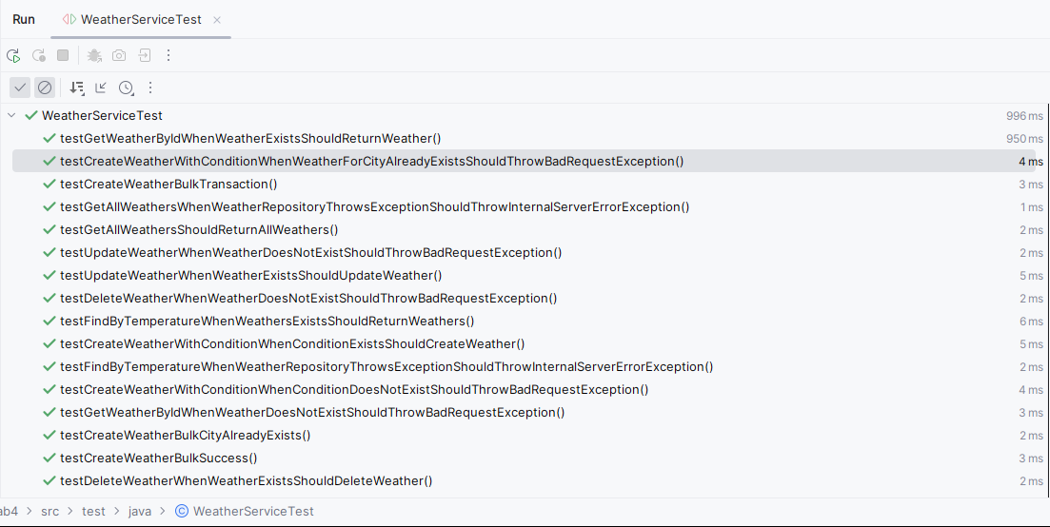
Рисунок 1.1 – успешное выполнение тестов

5. Заключение

В результате работы были добавлены POST методы для работы со списком параметров (передающимися в теле запроса) для bulk операций, организована работа сервиса используя Java 8 (Stream API, лямбда-выражения). Было выполнено покрытие Unit-тестами на >80% (бизнес-логика).

